UQ Winter Research Project Description

Project title: | Literature Review & Infographic
Hours of engagement & delivery mode | The project duration for the 2024 Winter program is 4 weeks from 24 June-19 July 2024.  Expected hours of engagement are 20 hours per week or 80 hours in total. This could be completed as 5 x 4hr days, or you could also break up your weekly hours differently if/as needed to work around other commitments you might have over the program period.  You can complete this work remotely, on campus in common areas, or there is also a SCL lab with desktop computers available for you to work from if needed, up to a maximum of 4 hours per day.  You will be expected to attend the following sessions with the Social Change Lab, in addition to any compulsory sessions hosted by the program coordinators:  - A one-hour group orientation session with your Social Change Lab supervisors and fellow Winter scholars at the beginning of the program, in-person but with a zoom option for anyone not able to attend face-to-face.  - One-hour weekly zoom group consultation sessions with your SCL supervisors for academic/research support.  In addition, you will also be invited to attend (not compulsory):  - One-hour weekly zoom check-in meetings for practical support.  - A group presentation session with fellow Winter scholars towards the end of the program where you will have the opportunity to present your work.  - A social gathering after the presentation session to mark the end of the program, celebrate your accomplishments, and reflect on your experiences and the new skills you have learned.  - You are also encouraged to attend any relevant skills training workshops advised by program coordinators that are scheduled during the program.  We will accept up to 6 students working in pairs across 3 different projects, with the specific research topics for the projects to be advised as we develop those closer to the time.
Description: | The project will focus on a specific topic relevant to the research areas covered by researchers in the Social Change Lab. You will be asked to explore and engage previous research on the topic. This project involves looking at the psychological research as well as interdisciplinary research in other areas. The specific research topics for the projects will be advised closer to the time.
Expected learning outcomes and deliverables: | There are a series of outcomes and deliverables we would like for this project, and these are listed below. As a minimum, we would expect Winter scholars to complete the literature review and infographic (points 1 and 2) and students can work through as many of the remaining deliverables as they can in the time available.  - A comprehensive and systematic literature review  - A Google Sheet template will be set up in a Google folder specifically for you and this will be shared with you – please see example excerpt below.  - A detailed briefing of how to populate the Google Sheet will be provided to you at the beginning of the project.  - You will be asked to save pdf copies of all available papers found in your Google folder.  Example  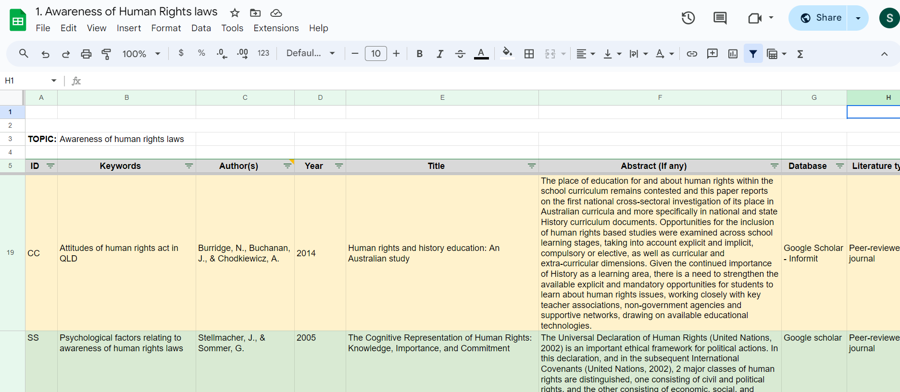  - From the literature review, prepare a one-page summary in the form of an infographic:  - Want this to be accessible to a community audience and therefore as free from methodological or theoretical jargon as possible and visualisations and images are preferred over lots of words.  - It is essential you ensure that any images or other non-original content (i.e., not of your own creation) you choose to include in your infographic has the appropriate permissions for it to be reproduced and is not limited by copyright.  - This is important if we want to make the infographic available on the SCL website and other public channels including potentially The Commons Social Change Library, which provides free educational material and resources on social change topics in digital format and that is directly available without copyright limitations.  - Ideally, any such images or other content will be your original work, available via Creative Commons licenses, or the content creator has otherwise granted permission for it to be reproduced for educational purposes.  - Some AI generated content may qualify but please check these details to be sure.  - We need to take content copyright seriously to prevent potential problems down the track, including opportunistic claims for financial compensation, threat of litigation, etc.  - Therefore, we ask that you please use only copyright free images/content in your infographic and keep a detailed record in a Google sheet of the source of any such content, including a screenshot of the copyright permission. Please save the file in your project folder on the Google drive.  - From the literature review, identifying potential research IVs and DVs at a conceptual level.  - Operationalisation of the IVs and DVs that have been identified.  - Drafting questions suitable for a research questionnaire/survey.  - Drafting the research ethics application.  - As an additional voluntary activity if they choose to do so, the student(s) would be welcome to give a short talk to a meeting of the Social Change Lab at the end of the project to present their work and reflect on their experiences and the new skills they have learned.
Suitable for: | This project is open to applications from 3rd – 4th year students only, with a grade of 5, 6 or 7 in PSYC3010 (psychological research methods III).  Students must have a demonstrated record of excellence in research methods, and the capacity to work independently but also as part of a pair.
Primary Supervisor: | Professor Winnifred Louis
Further info: | Questions are ok and can be submitted prior to applying to Christine McCoy at c.mccoy@uq.edu.au. Applicants will be decided based on grades, CV, and possibly interviews at the time.

