UQ Summer Research Project Description
Please use this template to create a description of each research project, eligibility requirements and expected deliverables. Project details can then be uploaded to each faculty, school, institute, and centre webpage prior to the launch of the program.

Project title: | The politics of fear
Project duration, hours of engagement & delivery mode | Project duration of 6 weeks commencing week of 15/01/2024 and ending by 25/02/2024.  Offering 29 hours, or 4 x 7.25hr days, per week for the first 4 weeks and a lighter load of 20 hours per week in the last 2 weeks (156 hours in total).  There will be a one-hour weekly Zoom check-in meeting that all of our lab’s Summer Scholars will be invited to attend, as well as a one-hour weekly face-to-face drop-in session also available to all of our Summer Scholars.  Project can be completed under a remote working arrangement. Can be done remotely with Zoom co-working and meetings as required.  We are happy to accept up to two students for this project.
Description: | The project will consider psychological factors relating to the politics of fear. We will ask you to explore and engage previous research on why leaders move towards fear-oriented policy, when and why it appeals to voters and community members, and why media outlets promote fear narratives. This project involves looking at the psychological research as well as interdisciplinary research in other areas. The literature review will build towards and inform possible experimental research testing the impacts of diverse messages and developing interventions.
Expected outcomes and deliverables: | There are a series of outcomes and deliverables we would like for this project and the student(s) can work through as many as these as possible in the time available.  - A comprehensive and systematic literature review  - Expected outputs are:  - Google Sheet (title should be the research topic) listing all papers reviewed (referenced in APA 7 format and always including the doi whenever available), any related notes and a link to where the pdf of the paper has been saved on your Google Drive  (see example below)  Example  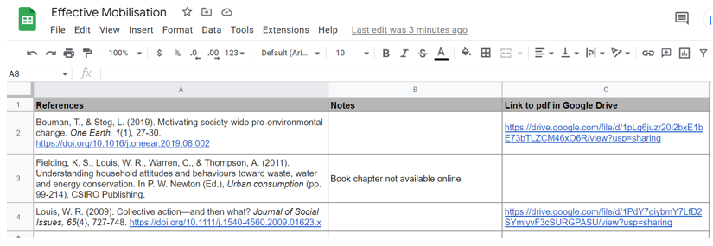  - An annotated bibliography prepared in a Google Docs file which should include the APA reference and then, underneath that, dot point notes describing:  - Who was studied (e.g., 10 Queensland women)  - What was done in the study (e.g., Life histories collected in 2010)  - What they found (e.g., They found that xxxx)  - A separate Google Docs file containing a list of all of the measures used in the surveys reported in the papers reviewed, either the questionnaire name or the actual items, and each one with its accompanying reference cited  - A narrative summary consisting of the following for each paper a) a one paragraph summary of the paper, and b) a summary of that paper’s key findings and themes.  - From the literature review, prepare a one-page summary in the form of an infographic  - Want this to be accessible to a community audience and therefore as free from methodological or theoretical jargon as possible  - From the literature review, identifying potential research IVs and DVs at a conceptual level  - Operationalisation of the IVs and DVs that have been identified  - Drafting a research questionnaire/survey  - Drafting the research ethics application  - As an additional voluntary activity if they choose to do so, the student(s) would be welcome to give a short presentation to a meeting of the Social Change Lab at the end of the project to reflect on their experiences and the new skills they have learned.
Suitable for: | This project is open to applications from 3rd – 4th year students only, with a grade of 5, 6 or 7 in PSYC3010 (psychological research methods III).  Students must have a demonstrated record of excellence in research methods, and the capacity to work independently but also as part of a pair.
Primary Supervisor: | Professor Winnifred Louis
Further info: | Questions are ok and can be submitted prior to applying to Christine McCoy at c.mccoy@uq.edu.au. Applicants will be decided based on grades, CV, and possibly interviews at the time.

